EdAssist
Change Management PLAN
Version 1.1
03/06/2022

VERSION HISTORY
Version  # | Implemented  By | Revision  Date | Approved  By | Approval  Date | Reason
1.0 | EdAssist Team | 02/18/22 | Sir Fahad Javed | 02/24/22 | Initial version
1.1 | EdAssist Team | 02/19/22 | Sir Fahad Javed | 02/27/22 | Changed the project scope (removed grading module)
1.2 | EdAssist Team | 03/06/22 | Sir Fahad Javed | 04/28/22 | Change in project scope (removed attendance module
UP Template Version: 11/30/06

TABLE OF CONTENTS
1 Introduction 5
1.1 Purpose of The Change Management Plan 5
2 Change management Process 5
2.1 Change Request Process Flow Requirements 5
2.2 Change Request Form and Change Management Log 6
2.3 Evaluating and Authorizing Change Requests 6
2.3.1 Change Control Board 7
3 Responsibilities 7
Appendix A: Change Management Plan Approval 8
Appendix B: References 9
Appendix C: Key Terms 10
Appendix D: Change Request Form Example 11

Introduction

Purpose of The Change Management Plan
The purpose of changing the scope of our project is to maintain the simplicity of our project as well as avoid any repetition of modules among other project teams. Since this module is being implemented by another project team, we plan to collaborate and develop a system having both, the PTM scheduler and the attendance modules.

Change management Process
The Change Management process establishes an orderly and effective procedure for tracking the submission, coordination, review, evaluation, categorization, and approval for release of all changes to the project’s baselines.

Change Request Process Flow Requirements
- Once the team agrees to remove the attendance module from the scope of the project, the change request (CR) form will be filled out by the submitter.
- The form will then be sent to the change manager.
- The change manager will update the CR Log. Alongside, the Change Control Board (CCB) will review the CR and will develop a solution for the proposed change.
- If the team gets the approval, it will incorporate the suggested change into the project by making required adjustments.
- Lastly, the team will communicate the CR status to the submitter and all the stakeholders of the project.
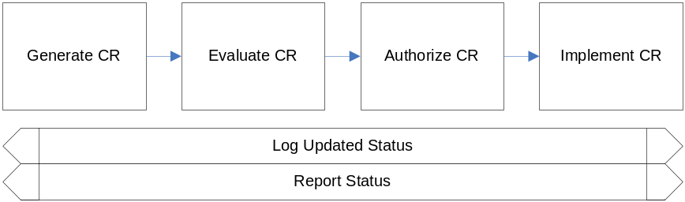

Change Request Form and Change Management Log
Element | Description
Date | 6th March 2022
CR# | Assigned by the Change Manager
Title | Change in Project Scope (Removing Attendance Module)
Description | The change in scope of the project is being made due to the constraint on time. Instead of two modules which were attendance and PTM scheduler, one module will be implemented under this project, whereas the project team aims to integrate the software with another team implementing the attendance module. It would help the team in developing the module within the given time limit and avoid any repetition of tasks among different groups.
Submitter | Sana Fatima
E-Mail | sf06199@st.habib.edu.pk
Product | EdAssist
Version | Version 1.1
Priority | High

Evaluating and Authorizing Change Requests
Change requests are evaluated using the following priority criteria:
Priority | Description
High | The change is immediately needed to avoid any major impact. Change approval is needed by the Project Lead
Medium | The change will solve any issues or repair missing functionalities. The change can be scheduled.
Low | The change will help making improvements in the existing system. The change can be scheduled.

Change requests are evaluated and assigned one or more of the following change types:
Type | Description
Scope | The change is affecting the scope of the project, reducing it from two modules to a single module (PTM scheduler)
Time | The change will reduce the time therefore the team will be able to complete the project under the given time constraint i.e. by 20th May 2022
Duration | The change will reduce the duration of the project (28th April – 20th May)
Cost | Not applicable
Resources | No change
Deliverables | If the change is approved, the team will only deliver the module of the PTM scheduler
Product | The product will remain the same as the team will coordinate with another project team (of the same course) to get the module on attendance
Processes | The change will reduce the processes to half (approx.) as no implementation of the attendance module will be done.
Quality | No change

Change requests are evaluated and assigned one of the following status types:
Status | Description
Open | Entered/Open but not yet approved or assigned
Work in Progress | CR approved, assigned, and work is progressing
In Review | CR work is completed and in final review prior to testing
Testing | CR work has been reviewed and is being tested
Closed | CR work is complete, has passed all tests, and updates have been released.

Change Control Board
Role | Name | Contact | Description
Head of CCB | Sir Fahad Javed | fahad.javed@sse.habib.edu.pk | He is also the project lead of all the project teams of L2. There are a total of 7 projects under his supervision. Each project is implementing different modules of the LMS.

Responsibilities
Role | Name | Contact | Description
Change Manager | Sir Fahad Javed | fahad.javed@sse.habib.edu.pk | He is the representative of all the stakeholders and has the authority of making decisions on requested changes.
Appendix A: Change Management Plan Approval
The undersigned acknowledge they have to review EdAssist Change Management Plan and agree with the approach it presents. Changes to this Change Management Plan will be coordinated with and approved by the undersigned or their designated representatives.

Signature: |  | Date:
Print Name:
Title:
Role:

Appendix B: References
The following table summarizes the documents referenced in this document.
Document Name and Version | Description | Location
EdAssist  Version 1.2 | SRS of the Project (Latest version) | EdAssist SRS - Version 1.2

Appendix C: Key Terms
The following table provides definitions for terms relevant to this document.
Term | Definition
Change Manager | The person assigned to review changes for completeness prior to review
Change Control Board (CCB) | The group is responsible for making decisions on requested changes
Implementation | The validation of a change to a facility.
Change Request (CR) | Request submitted to make changes to the system, model, or services defined in the latest SRS version.

Appendix D: Change Request Form Example
The example Change Request From attached below can be used to submit changes during the life of the project.
